Parth Babbar

wealth management services

**Introduction:**

Wealth management is a complete service created for high-net-worth people (HNWIs) and ultra-high-net-worth individuals (UHNWIs), with an emphasis on preserving and developing their long-term assets. This comprehensive strategy combines a variety of financial services, including investment advising, retirement planning, estate planning, and tax services, all customised to the unique needs of affluent customers. money management seeks to cover all elements of a client's financial life by offering personalised financial solutions, ensuring that their money is successfully managed and conserved for future generations.

**Importance in US Banking Sector:**

Wealth management is an important area of the US banking industry. It enables banks to diversify their revenue streams, strengthen client relationships, and keep high-value clients. It also enables banks to provide value-added services beyond typical banking products.

**Key Components:**

1. **Investment Management:** Investment management is the process of managing financial assets and other investments such as stocks, bonds, real estate, and alternative investments to help customers achieve specified financial goals. Portfolio management, which focuses on developing and maintaining diverse investment portfolios, and asset allocation, which finds the best mix of asset classes depending on clients' risk tolerance and financial goals, are two critical components. Furthermore, numerous investment methods, such as growth, value, income, and alternative investments, are used to attain the desired results for customers.
2. **Financial Planning:** It is a complete approach to financial management that aims to provide personal economic pleasure. It include developing techniques such as budgeting, saving, investing, and risk management to achieve personal objectives. Retirement planning focuses on devising ways to guarantee that customers can retire comfortably, whereas education planning tries to save for the educational requirements of children or grandkids. Furthermore, estate planning is critical in preparing for the effective transfer of wealth and lowering estate taxes, providing a solid financial future for future generations. These parts work together to create the basis of efficient financial planning, which is tailored to each client's individual requirements and goals.
3. **Estate Planning:** Estate planning is the meticulous arrangement of maintaining and dispersing an individual's assets throughout and after their lifetime. It seeks to protect wealth, reduce taxes, and guarantee that assets are transferred to designated recipients as planned. Wills and trusts are important legal tools that create formal frameworks for wealth management and distribution. Wealth transfer solutions improve tax efficiency while assuring the secure transmission of inheritances. This method ensures that financial legacies are secured and personal preferences are rigorously carried out.
4. **Risk & Insurance Management:** Risk management identifies and prioritises risks, reducing their effect via collaborative efforts. Insurance is important because it protects you financially from any losses. Life insurance provides for dependents after the client's death, long-term care insurance covers additional care expenditures, and disability insurance protects income during illness or accident. Individuals and families benefit from these solutions, which decrease financial risks and provide protection and peace of mind.

**Regulatory:**

1. **Key Regulatory Bodies:** 1.Office of the Comptroller of the Currency (OCC)  
    2.Federal Reserve System (Fed)  
    3.Federal Deposit Insurance Corporation (FDIC)
2. **Important Regulations and Acts:** 1.Dodd-Frank Wall Street Reform and Consumer Protection Act  
    2.Securities Act of 1933  
    3.Securities Exchange Act of 1934  
    4.Bank Secrecy Act (BSA)  
    5.Gramm-Leach-Bliley Act (GLBA)

**Technology:**

1. **The Role of FinTech:** FinTech technologies have revolutionised wealth management by automating operations, boosting data analysis, and increasing client involvement.
2. **Digital Platforms and technologies:** Digital platforms and technologies allow for seamless communication between clients and wealth managers. They offer real-time access to account data, performance statistics, and financial planning tools.

**Challenges:**

1. **Technological Disruptions:** In order to remain competitive and match customer expectations, companies must constantly adapt and invest in new technology.
2. **Client Expectations:** Today's clients need personalised and responsive services. Meeting these expectations while keeping expenses under control and maintaining scalability is a tough task.
3. **Market Volatility:** Wealth managers have considerable obstacles in achieving consistent returns for customers in the face of changeable market circumstances.

**Statistics:**

1. According to the most recent study, the worldwide Wealth Management market was valued at $1.53 trillion in 2022 and is predicted to grow at a CAGR of 10.79% over the forecast period, reaching $ 2.83 trillion by 2028.  
   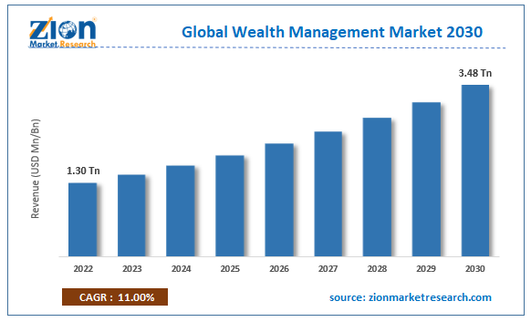
2. As of 2023, the United States has more than 12 million high-net-worth people (HNWIs) with a total fortune of $58 trillion. Millennials are expected to inherit $68 trillion over the next 25 years, greatly altering asset management strategies. This wealth transfer will redefine efforts to meet the changing requirements of younger generations in the financial environment.

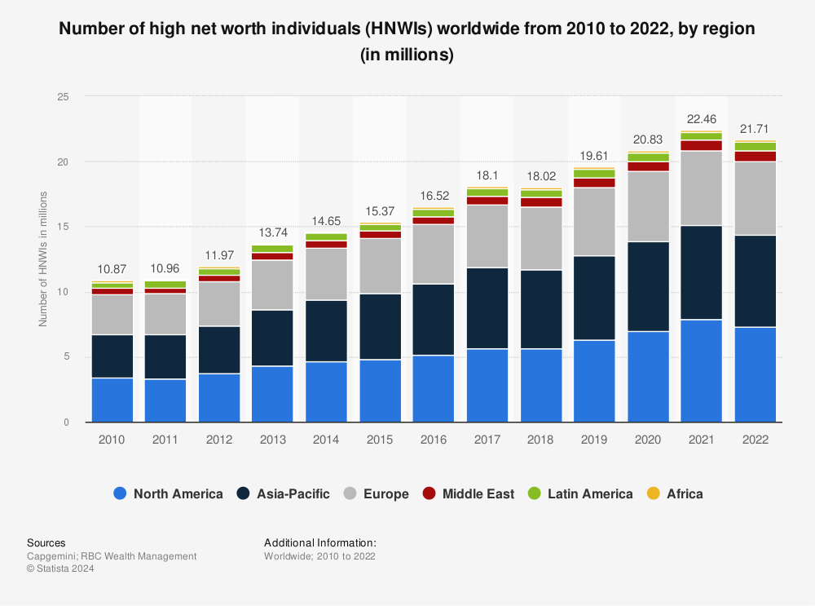

**Conclusion:**

Wealth management is a vibrant and vital component of the US banking industry, providing a wide range of services to fulfil the complicated financial demands of affluent clientele. To compete in today's competitive market, wealth management organisations must remain nimble and inventive as technology, legal frameworks, and client expectations evolve. Wealth managers may give exceptional value and achieve long-term success by embracing sophisticated technology while being client-centric.